Drive route :

Starhub SRVCC:

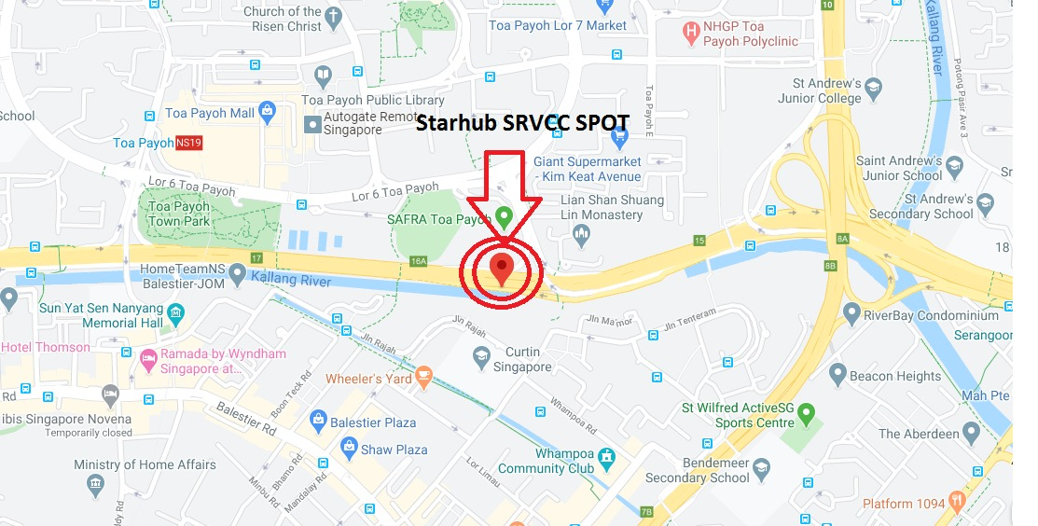

Singtel 5G good coverage:

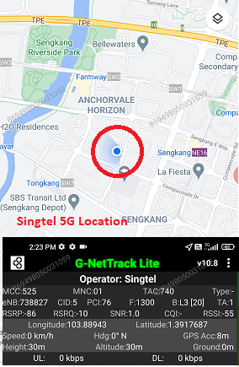

M1 Good coverge 5G spot:

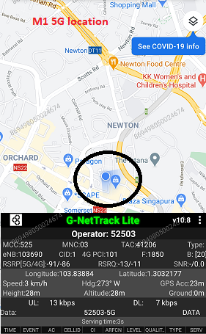

Srvcc SPOT for all three operaor:

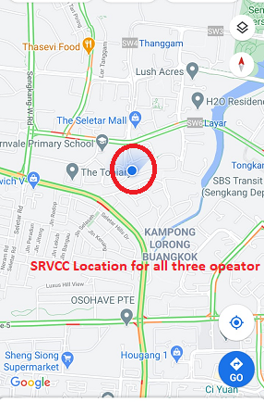

5G NSR TO LTE handover spot for M1 opertor:

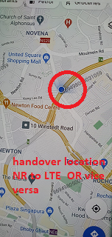

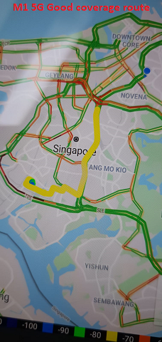

M1 and Singtel 5G good coverage common spot:

