EMPLOYEE MEDICAL SELF DECLARATION FORM

Please specify if you’re having health issue: YES/NO  If yes, please specify in detail: NO  Suffering from any chronic diseases: YES/NO  If yes, please specify in detail: NO  Undergoing any Medical Treatment: YES/NO  If yes, please specify in detail: NO  I, ARYAN UMESH PATIL | Of 1ST FLOOR NEEL KIRAN BUILDUING CHITTARANJAN DAS ROAD , RAMNAGAR DOMBIVLI EAST
(Applicant’s Name) | (Applicant’s Address)
Agree as an applicant being a fit and proper person and able to perform the inherent requirements of the position.
I do sincerely declare that the contents of this form are true and correct and complete to the best of my knowledge and no information concerning my past or present state of health has been withheld. I understand that any wilfully incorrect or misleading answer or material omission which relates to any of the questions before mentioned may make me ineligible for employment, or if employed, liable to disciplinary action which may include dismissal. I understand that this pre-employment health declaration may form part of my file.
I also voluntarily and freely consent to sharing of the above personal information in relation job employment to Marquis Technologies Pvt. Ltd
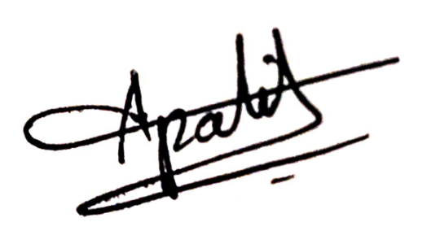
Applicant’s signature Date: 12/02/2025

